Write, implement, and demonstrate using Atmel Studio 7 a C code for the AVR  
ATMEGA328p microcontroller that performs the following functions:  
You’ll use the ADC, and PWM/CCP Module of the ATmega328/p to set and determine  
the speed of the DC Motor.

1. Using the Potentiometer connected to ADC0, translate the ADC value (0~1023) to  
PWM value/speed of the motor (0~255 if using Timer0/2). Verify the operation.

2. Using the CCP capture pin of PWM1, in mode 1x determine the speed of the DC  
Motor for a set ADC Pot value/position.

3. Develop a UART GUI interface to override the ADC speed control, the user input  
will control the speed of the motor. Plot the set speed and current speed using a  
UART GUI tool.

**Components Used/Connected**

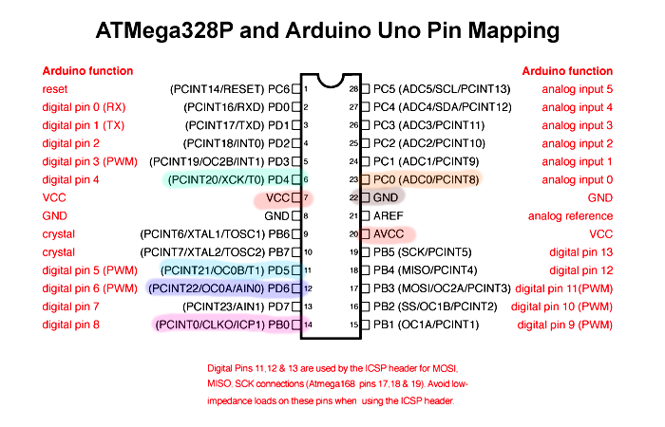

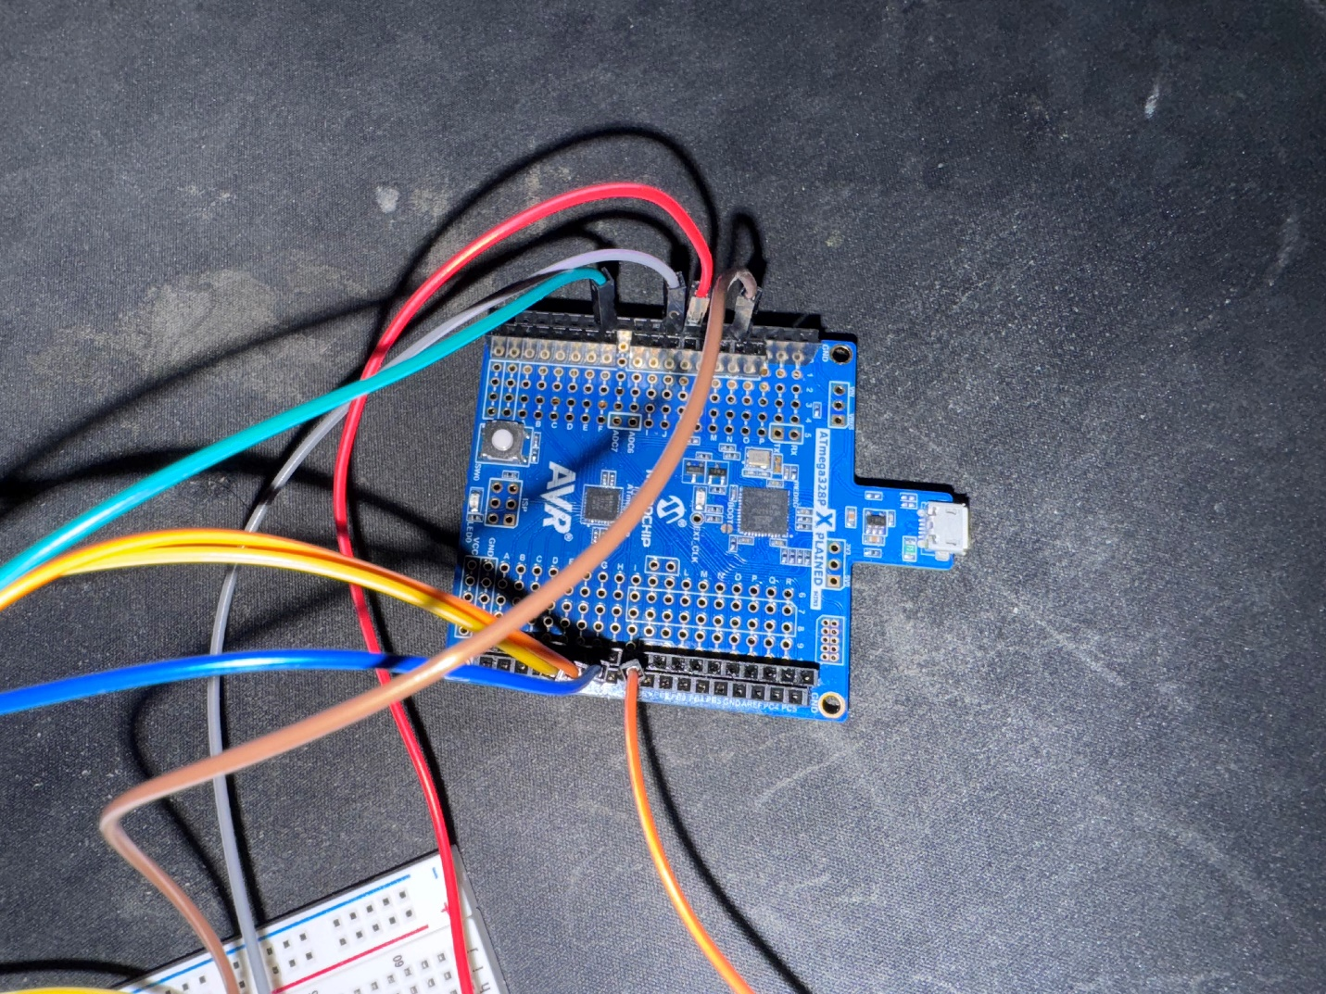

Atmega328p wiring

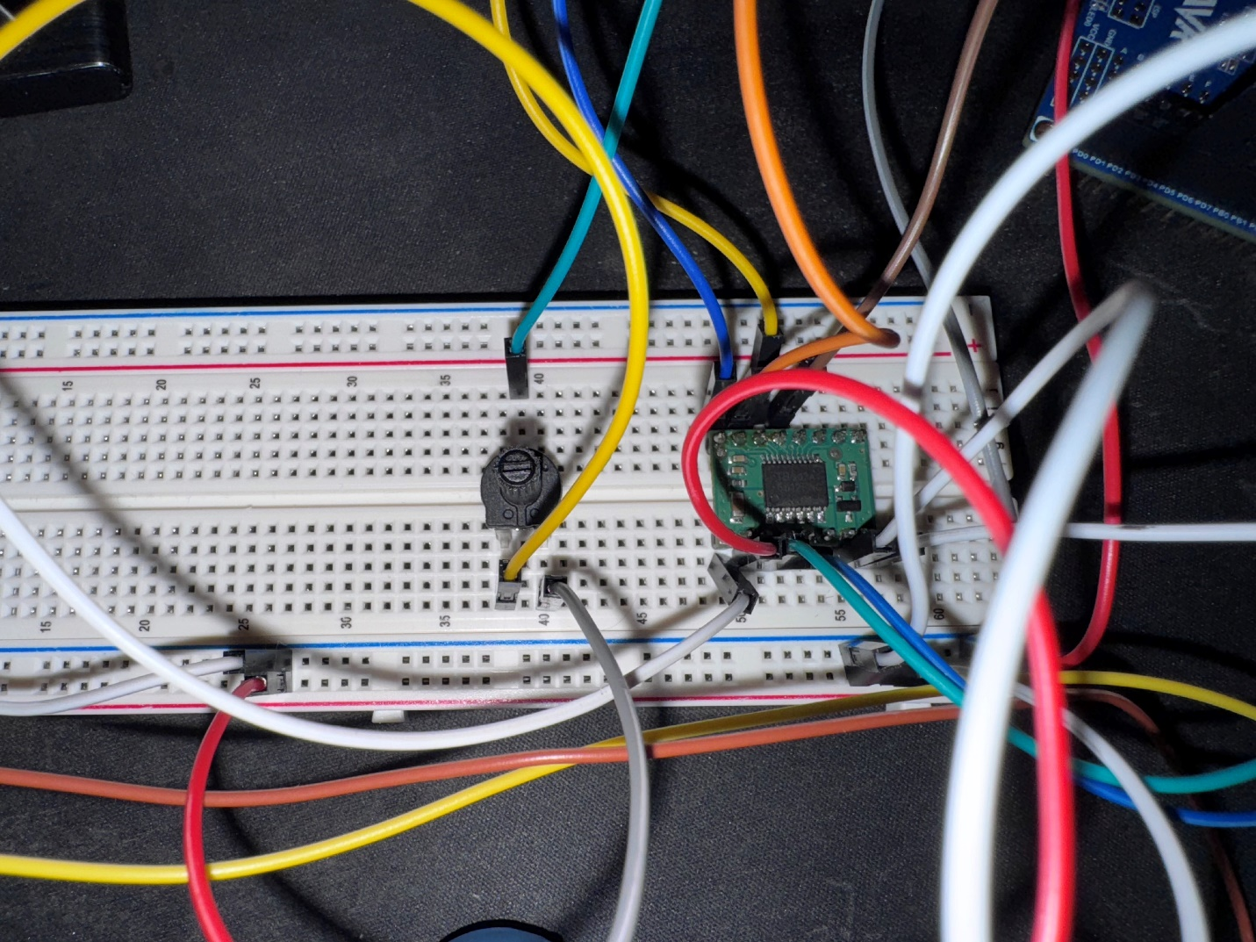

Breadboard layout.

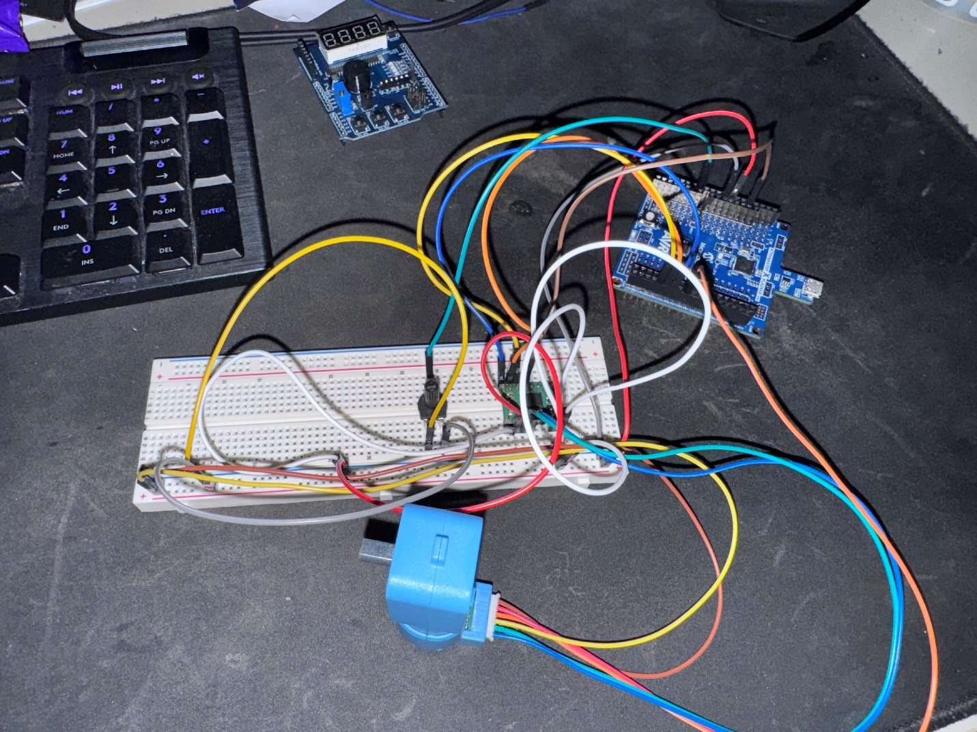

Whole setup.

Schematic showing how everything was set up.

**AVR C Code**

/*

* DA5.c

*

* Created: 4/28/2025 10:44:50 PM

* Author : enriq

*/

#define F_CPU 16000000UL

#include <avr/io.h>

#include <avr/interrupt.h>

#include <util/delay.h>

#include <stdlib.h>

#include <stdio.h>

// Motor driver pins

#define IN1_PIN PD4

#define IN2_PIN PD5

#define PWM_PIN PD6

// Variables

volatile uint16_t icr_last = 0;

volatile uint16_t period_counts = 0;

volatile uint8_t new_period = 0;

uint8_t set_speed = 0; // 0–255, PWM

uint8_t measured_speed = 0; // 0–255, from measurement

// UART parsing

char rx_buf[4];

uint8_t rx_pos = 0;

uint8_t override_flag = 0;

uint8_t override_speed = 0;

// UART at 9600 baud

static int uart_putchar(char c, FILE *stream) {

while (!(UCSR0A & (1<<UDRE0)));

UDR0 = (uint8_t)c;

return 0;

}

static FILE uart_str = FDEV_SETUP_STREAM(uart_putchar, NULL, _FDEV_SETUP_WRITE);

void uart_init(void) {

UBRR0 = F_CPU/16/9600 - 1;

UCSR0B = (1<<TXEN0)|(1<<RXEN0);

UCSR0C = (1<<UCSZ01)|(1<<UCSZ00);

stdout = &uart_str;

}

// ADC

void adc_init(void) {

ADMUX = (1<<REFS0);

ADCSRA = (1<<ADEN)|(1<<ADPS2)|(1<<ADPS1);

}

uint16_t adc_read(void) {

ADCSRA |= (1<<ADSC);

while (ADCSRA & (1<<ADSC));

return ADC;

}

// PWM (PD6)

void pwm0_init(void) {

DDRD |= (1<<PWM_PIN);

TCCR0A = (1<<COM0A1)|(1<<WGM01)|(1<<WGM00);

TCCR0B = (1<<CS01);

}

// ICP1 (PB0)

ISR(TIMER1_CAPT_vect) {

uint16_t ic = ICR1;

period_counts = ic - icr_last;

icr_last = ic;

new_period = 1;

}

void icap_init(void) {

DDRB &= ~(1<<PB0);

TCCR1B = (1<<ICNC1)|(1<<ICES1)|(1<<CS11);

TIMSK1 = (1<<ICIE1);

}

// Motor direction pins (PD4/PD5)

void motor_dir_init(void) {

DDRD |= (1<<IN1_PIN)|(1<<IN2_PIN);

PORTD |= (1<<IN1_PIN); // IN1=1

PORTD &= ~(1<<IN2_PIN); // IN2=0 → forward

}

int main(void) {

motor_dir_init();

pwm0_init();

adc_init();

uart_init();

icap_init();

sei();

while (1) {

if (UCSR0A & (1<<RXC0)) {

char c = UDR0;

if (c >= '0' && c <= '9' && rx_pos < sizeof(rx_buf) - 1) {

rx_buf[rx_pos++] = c;

}

else if ((c=='\r' || c=='\n') && rx_pos) {

rx_buf[rx_pos] = '\0';

uint16_t v = atoi(rx_buf);

if (v > 255) v = 255;

override_speed = (uint8_t)v;

override_flag = 1;

rx_pos = 0;

}

}

// set_speed

if (override_flag) {

set_speed = override_speed;

} else {

uint16_t raw = adc_read();

set_speed = raw >> 2;

}

OCR0A = set_speed;

// Update measured_speed

if (new_period) {

new_period = 0;

if (period_counts) {

uint32_t freq = F_CPU/8/period_counts;

measured_speed = (freq > 255 ? 255 : (uint8_t)freq);

} else {

measured_speed = 0;

}

}

// Print on BAUD 9600

uint16_t temp = ADC; // last ADC reading

printf("%u %u %u\n", temp, set_speed, measured_speed);

_delay_ms(200);

}

}

Successful Compilation

Successfully reading values from motor and potentiometer.

The first value is ADC, second value is the potentiometer value, and third value is the measured speed.

SerialPlot test